Placeholder Title
Theo Devos-Vernes (C3479858)
MECH2110, Bachelor of Mechanical Engineering

Table of Contents
Table of Contents···········································································i
Table of Figures············································································ii
Introduction·················································································1
Final Solution··············································································x
Components and Hardware······························································ x
Manufacturing··············································································x
Risk Management··········································································x
Testing and Evaluation····································································x
Self-Reflection·············································································x
Conclusion··················································································x

Table of Figures
Figure 1·····················································································x
Figure 2·····················································································x
Figure 3·····················································································x
Figure 4·····················································································x
Figure 5·····················································································x
Figure 6·····················································································x
Figure 7·····················································································x
Figure 8·····················································································x
Figure 10····················································································x
Figure 11····················································································x
Figure 12····················································································x

Introduction
The Warman Design and Build Competition is a multi-university challenge, designed to teach groups of six students how to effectively design and build systems, evaluate prototypes, project manage and troubleshoot by having them build semi-autonomous devices to complete a given task. Each year group receives a different challenge, with this year’s challenge (see Fig. 1 for overview of course) featuring a walled rock collection zone, a large ramp to the middle platform of a multi-level structure, and a hopper placed on top of the upper floor of the same structure. Depositing the rocks in the hopper would score maximum points per rock, while placing them on each progressively lower floor would yield less points, with the minimum points per rock (without dropping them) achieved by depositing them on the ground floor of the structure. Points would also be awarded for the device disturbing and collecting each of the rocks, finishing in the correct area of the course, and the time taken to complete the course.

Our group initially aimed to place rocks on the upper platform of the structure, while ensuring our device had the capability to deposit in the hopper. We figured this would be possible with relative ease, while keeping our options open for higher marks. The initial concept for transporting the device was a simplified continuous track (see Fig. 2) on each side of our machine, with an excavator-like mechanism (see Fig. 3) attached to a custom-made mud bucket for rock collection. All of this would be controlled by two interlinked Arduino Uno R3s (3 if more signal pins were required). Many of the other details were left open at the time to focus on making the crucial mechanisms work first, before expanding our scope for the less important segments of the design.
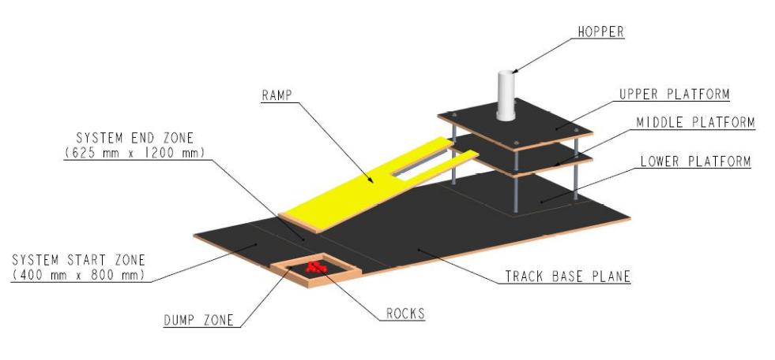
Figure 1. Schematic view of the 2026 Competition Track showing the track base plane, ramp, platforms, deposit zone, hopper, and end zone. [1]

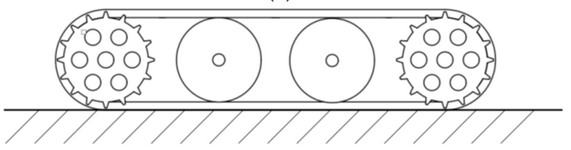
Figure 2. A simplified continuous track with two drive wheels and two idler wheels. [2]

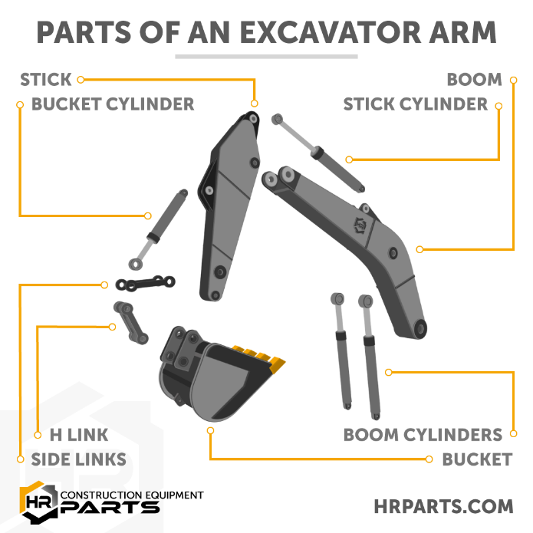
Figure 3. Diagram of the various parts of an excavator arm. [3]

Final Solution
Components and Hardware
Manufacturing
Risk Management
Testing and Evaluation
Self-Reflection
Conclusion
Bibliography
[1] Engineers Australia, “39th Warman Design and Build Competition Rules,” Engineers Australia, 2026. https://warmandesignandbuild.org.au/

[2] M. Fiedeń and J. Bałchanowski, “A Mobile Robot with Omnidirectional Tracks—Design and Experimental Research,” Applied Sciences, vol. 11, no. 24, p. 11778, Dec. 2021, doi: https://doi.org/10.3390/app112411778.

[3] HR Parts, “How Does an Excavator Arm Work | Basic Details, Images, and Animated Diagram,” www.hrparts.com, Oct. 26, 2022. https://www.hrparts.com/blog/post/how-does-excavator-arm-work-diagram

